Lindenmayer Systems
Reuben Wiles Maguire
reuben.wiles--magu@yorksj.ac.uk

ABSTRACT
This paper focuses on the creation of a Lindenmayer System visualiser. This paper first outlines the basic theory of Lindenmayer Systems, then describes and evaluates the implemented systems.

Author Keywords
Lindenmayer Systems; L-Systems, Procedural Generation.

INTRODUCTION
This project focuses on the implementation of a Lindenmayer System visualiser. Lindenmayer Systems (L-Systems) are a parallel rewriting system that can be used to produce drawing instructions for fractal and plant-like structures. This technique can be used to procedurally generate textures for biological structures like trees and grass that “grow” realistically.
The primary goal of this project is to create a program that displays a visual representation of an L-System. Additionally, this project has four subgoals:
- create an L-System that accepts custom rule sets;
- create a functional user interface to control the L-System;
- create a stochastic L-System to allow for the generation of random structures; and
- create a program that can draw reasonably large L-Systems without a significant performance impact.

Lindenmayer Systems (L-Systems)
Lindenmayer systems (L-Systems) are a parallel rewriting system that was originally written to model the growth of multicellular organisms, which not only grow on their edges but throughout the entire organism (Kari, Rozenberg and Salomaa, 1997, pp. 1–2). L-Systems work by defining an alphabet of possible characters, production rules that describe how the system changes from one generation to the next, and an initial axiom to be expanded. Each generation, every applicable character in the current axiom will be replaced according to the production rules, creating a new axiom.

Callithamnion Roseum L-System Example
The Callithamnion roseum L-System is the original L-system proposed by Lindenmayer (Kari, Rozenberg and Salomaa, 1997, p. 3).
Alphabet: 1, 2, 3, 4, 5, 6, 7, 8, 9, [, ]
Production Rules:
1→23, 2→2, 3→24, 4→25, 5→65, 6→7, 7→8, 8→9[3], 9→9
Axiom: 1
Generation | Axiom
0 | 1
1 | 23
2 | 224
3 | 2225
4 | 22265
5 | 222765
6 | 2228765
7 | 2229[3]8765
Table 1: First seven generations of the Callithamnion roseum L-System. Based on Kari, Rozenberg and Salomaa (1997, p. 3)

Implementation
This project focused on the implementation of an L-System visualiser using turtle graphics in Python (Python Software Foundation, 2026a). The program maps each character in the L-System’s alphabet to a drawing action (e.g., draw forward, turn left, turn right) and then executes the current axiom as if it were a list of instructions.
The project was developed in three parts: the L-System, the turtle drawing system, and the user interface.

L-System
The implemented L-System was able to expand an axiom a specified number of times using a custom alphabet and production rules. Additionally, the L-System was stochastic, meaning multiple production rules could be assigned to the same value, each weighted by a probability, which the L-System would then select randomly from. This allowed the creation of rule sets that would produce different expansions each time the L-System was reset.

Turtle Drawing System
Initially, this project used Python’s Turtle graphics (Python Software Foundation, 2026b) module, however, initial testing determined that this method would be extremely slow as each instruction would be executed one at a time in real time. As such, a custom turtle was created; instead, create a list of all lines in the L-System first, then draw them all together.
Since the custom turtle produced a list of line coordinates, the L-System could be drawn as a graph. To implement this, three separate modules were tested using a simple L-System (see Appendix B): Matplotlib (The Matplotlib Development Team, 2025), VisPy (VisPy Developers, 2026), and ImPlot (Pezent, 2026) for Dear ImGui Bundle (Thomet, 2026).
Matplotlib is a popular scientific visualisation and graphing module, making it the natural first choice for this task. It proved capable of displaying the produced instructions up to the tenth generation (116,050 lines), after which the graph became unresponsive. While this would have been sufficient for this project, a more optimised approach would enhance the program's usability at high line counts and improve performance on weaker devices.
Similar to Matplotlib, VisPy is a scientific visualisation and graphing module; however, unlike Matplotlib, VisPy is based on OpenGL (Khronos Group, 2026) and utilises a device’s GPU to accelerate graph rendering. Repeating the tests using VisPy showed that the tenth generation had no significant performance reduction, and performance only began to slow around the sixteenth generation (85,962,370 lines), at which point the instruction generator itself began to impact performance negatively. Since this was, realistically, the program's limit, and because VisPy was more performant at lower generation counts, it was initially chosen as the graphing module for this project.
As development began on the Dear ImGui Bundle-based UI, ImPlot was discovered. Implot is a GPU-accelerated graphing module, like VisPy, except it is also specifically designed for the Dear ImGui Bundle interface library. As a result, ImPlot was also tested. Similar to VisPy, ImPlot was able to display the tenth generation without issue but began to experience a significant performance reduction around the thirteenth generation (3,172,262 lines). Although VisPy performed better than ImPlot, ImPlot was ultimately chosen for its UI integration and because its performance was still sufficient.

User Interface
This project used Dear ImGui Bundle (Thomet, 2026) to create a functional control panel for the L-System. The control panel provides basic generation controls such as “Next Axiom”, “Nth Axiom”, and “Reset”, as well as more complex controls that allow the initial axiom, alphabet, and production rules of the L-System to be modified to create custom rule sets. Custom rule sets can be saved to/ loaded from a JSON file.
When the user configures a custom alphabet or a custom set of production rules, they can also specify a minimum and maximum value, or a percentage chance, respectively, allowing them to create a stochastic rule set that will produce different L-Systems when run. The user can control this randomness by setting a custom seed, allowing them to save specific random generations.
The interface also features several warnings to prevent the user from accidentally generating an L-System that would make their device unresponsive, such as high-generation-count warnings and long-instruction-set warnings, and provides the user with the option to cancel or proceed with the hazardous generation. Additionally, since the user can customise the L-Systems settings, any action that would overwrite their custom settings also displays a warning.

EValuation
The program produced by this project implements the underlying L-System fairly successfully. The L-System works as described by the theory and produces the expected output for a given axiom, alphabet, and set of production rules (see Figure 1). Additionally, the implemented L-System was capable of handling stochastic production rules and alphabets, allowing it to produce both random and deterministic structures. However, the implementation is also very simple and has O(N) time complexity. Since the length of axioms produced by an L-System can increase exponentially, the implemented L-System begins to struggle once the generated axioms become hundreds of billions of characters long. Although, given its use in this project, where performance is first limited by the L-System's drawing, this issue is not particularly critical.
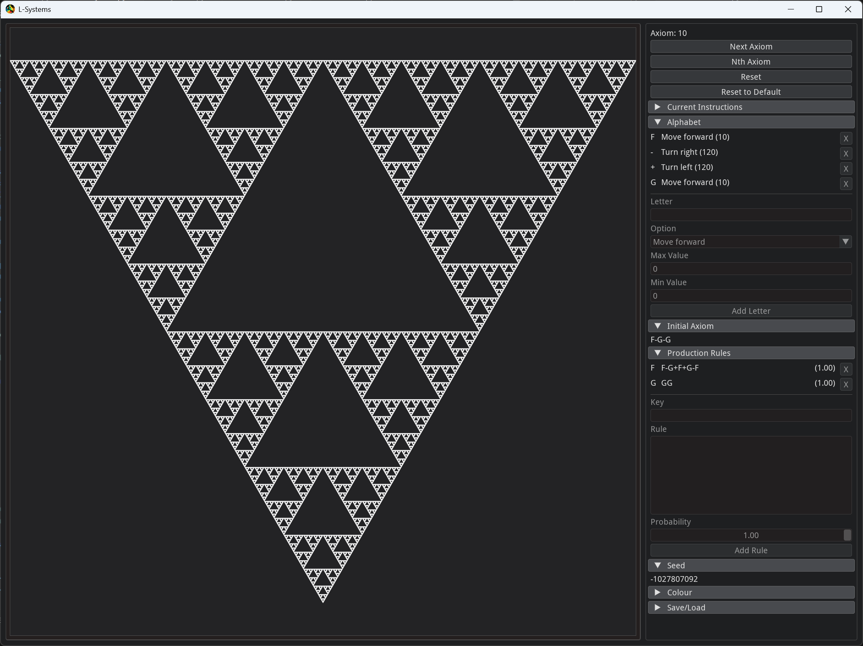
Figure 1: Sierpinski triangle generated using the L-System Program.
The drawing system was also implemented adequately, correctly converting the L-System instructions into the expected pattern. While the project identified a performant and compatible method for displaying the L-System, the implementation still suffers from performance issues at high generation counts. However, this issue will eventually plague all implementations as the instructions become exponentially longer.
Despite this, the performance of the implemented solution could be improved by optimising to reduce the number of lines drawn. For example, the fifth generation of the test L-System (see Appendix B, Figure 6) begins with the instructions “FFFFFFFFFFFFFFFF”. This would currently result in sixteen lines being drawn one after another, but could be optimised by drawing a single, longer straight line instead. Applying similar optimisations throughout the entire instruction set would drastically reduce the number of lines that need to be drawn and improve performance.
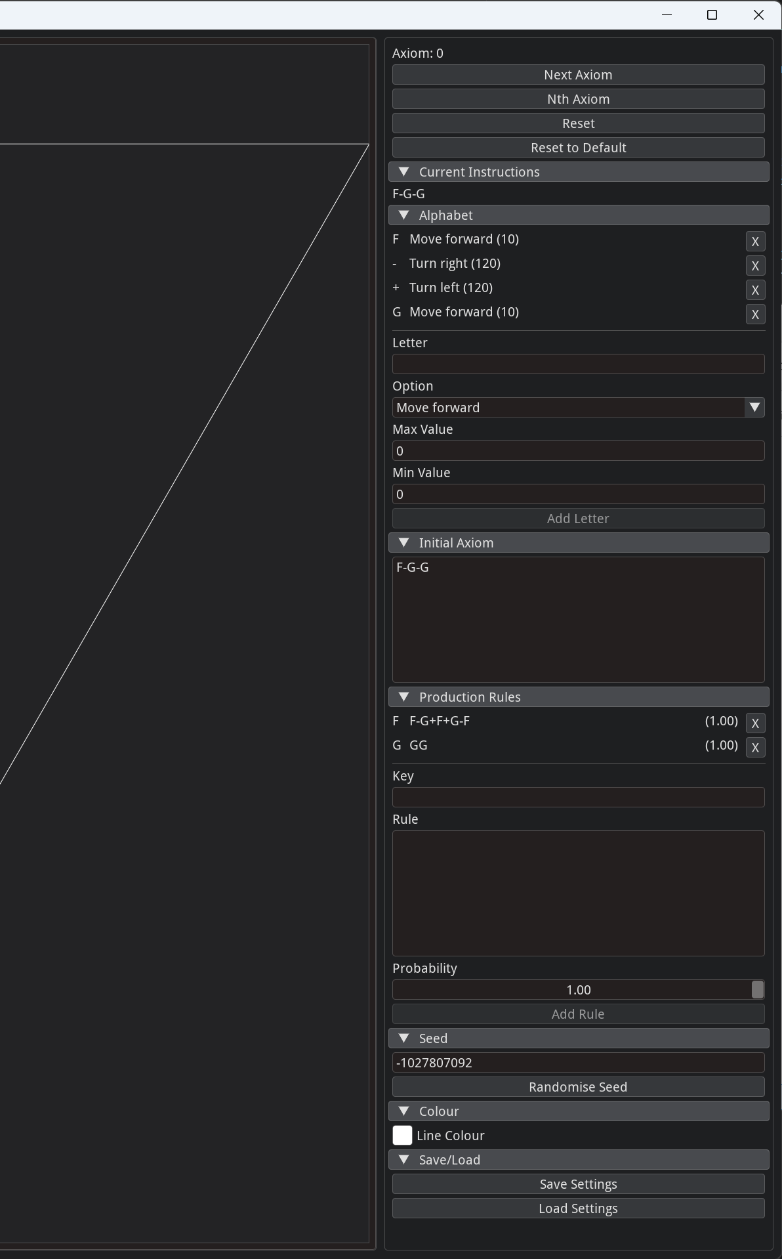
Figure 2: L-System controls UI.
Finally, the user interface was implemented successfully, allowing the user to control the L-System and assign custom alphabets, initial axioms, and production rules. The user interface also provided warnings when the user performed performance-heavy actions, giving them the option to stop and preventing them from overwhelming their device.
Additionally, the UI prevented the user from entering or executing incompatible custom rule sets, preventing the program from crashing due to incorrect inputs. The only exception to this is the file-loading system, which is designed to handle incompatible files, but does not fully verify the JSON structure beyond the top layer, meaning the program can be deliberately broken by loading a modified JSON file.

Conclusion
Overall, the L-System visualisation program developed in this project successfully implemented the underlying L-System, enabling visualisation of custom deterministic and stochastic L-System rule sets and achieving the project's primary goal. Additionally, the implanted systems performed well within their expected use cases, but could be improved upon to increase performance at higher generation counts.

REFERENCES
Kari, L., Rozenberg, G. and Salomaa, A. (1997) ‘L Systems’, in G. Rozenberg and A. Salomaa (eds) Handbook of Formal Languages. Berlin, Heidelberg: Springer Berlin Heidelberg, pp. 253–328. Available at: https://doi.org/10.1007/978-3-642-59136-5_5.
Khronos Group (2026) ‘OpenGL’ [Software]. Available at: https://www.opengl.org/ (Accessed: 14 June 2026).
Pezent, E. (2026) ‘ImPlot’ [Software]. Available at: https://github.com/epezent/implot (Accessed: 13 June 2026).
Python Software Foundation (2026a) ‘Python’ [Software]. Python Software Foundation. Available at: https://www.python.org/ (Accessed: 13 June 2026).
Python Software Foundation (2026b) ‘Turtle graphics’ [Software]. Available at: https://docs.python.org/3.13/library/turtle.html (Accessed: 13 June 2026).
The Matplotlib Development Team (2025) ‘Matplotlib’ [Software]. Available at: https://matplotlib.org/ (Accessed: 13 June 2026).
Thomet, P. (2026) ‘Dear ImGui Bundle’ [Software]. Available at: https://imgui-bundle.pages.dev/ (Accessed: 13 June 2026).
VisPy Developers (2026) ‘VisPy’ [Software]. Available at: https://vispy.org/ (Accessed: 13 June 2026).

Appendix
Appendix A: Source code of the L-System program.
Available at: https://github.com/GroobTM/L-Systems

Appendix B: L-System setup used during Turtle Drawing testing and first five generation outputs.
Alphabet:
F (Forward 10), + (Left 30°), - (Right 30°), [ (Save state), ] (Load state), X (Nothing)
Production Rules:
X→F[+X][-X]FX, F→FF

Axiom: X
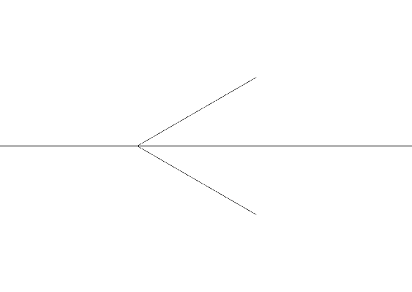
Figure 3: Generation 1, Instructions: F[+X][-X]FX
Figure 4: Generation 2, Instructions: FF[+F[+X][-X]FX][-F[+X][-X]FX]FFF[+X][-X]FX
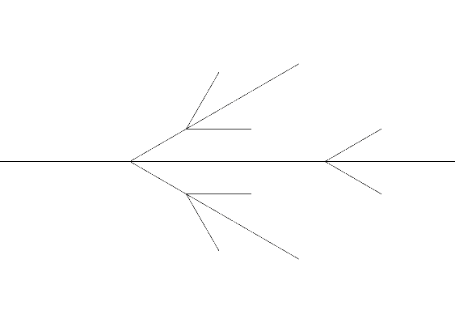
Figure 5: Generation 3, Instructions: FFFF[+FF[+F[+X][-X]FX][-F[+X][-X]FX]FFF[+X][-X]FX][-FF[+F[+X][-X]FX][-F[+X][-X]FX]FFF[+X][-X]FX]FFFFFF[+F[+X][-X]FX][-F[+X][-X]FX]FFF[+X][-X]FX
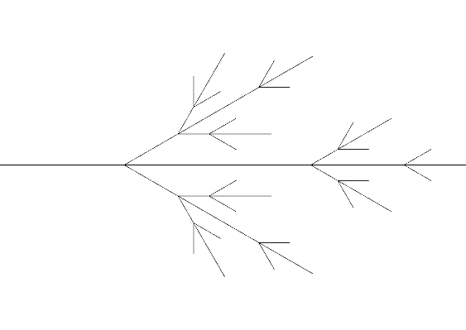
Figure 6: Generation 4, Instructions: FFFFFFFF[+FFFF[+FF[+F[+X][-X]FX][-F[+X][-X]FX]FFF[+X][-X]FX][-FF[+F[+X][-X]FX][-F[+X][-X]FX]FFF[+X][-X]FX]FFFFFF[+F[+X][-X]FX][-F[+X][-X]FX]FFF[+X][-X]FX][-FFFF[+FF[+F[+X][-X]FX][-F[+X][-X]FX]FFF[+X][-X]FX][-FF[+F[+X][-X]FX][-F[+X][-X]FX]FFF[+X][-X]FX]FFFFFF[+F[+X][-X]FX][-F[+X][-X]FX]FFF[+X][-X]FX]FFFFFFFFFFFF[+FF[+F[+X][-X]FX][-F[+X][-X]FX]FFF[+X][-X]FX][-FF[+F[+X][-X]FX][-F[+X][-X]FX]FFF[+X][-X]FX]FFFFFF[+F[+X][-X]FX][-F[+X][-X]FX]FFF[+X][-X]FX

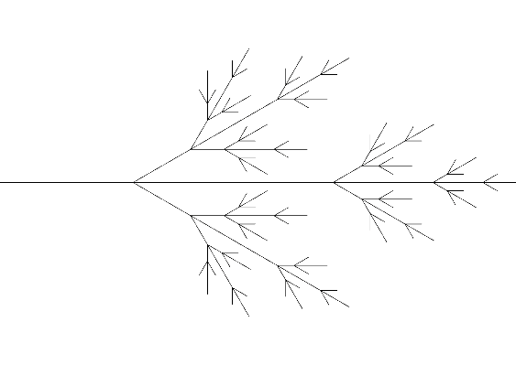
Figure 7: Generation 5, Instructions: FFFFFFFFFFFFFFFF[+FFFFFFFF[+FFFF[+FF[+F[+X][-X]FX][-F[+X][-X]FX]FFF[+X][-X]FX][-FF[+F[+X][-X]FX][-F[+X][-X]FX]FFF[+X][-X]FX]FFFFFF[+F[+X][-X]FX][-F[+X][-X]FX]FFF[+X][-X]FX][-FFFF[+FF[+F[+X][-X]FX][-F[+X][-X]FX]FFF[+X][-X]FX][-FF[+F[+X][-X]FX][-F[+X][-X]FX]FFF[+X][-X]FX]FFFFFF[+F[+X][-X]FX][-F[+X][-X]FX]FFF[+X][-X]FX]FFFFFFFFFFFF[+FF[+F[+X][-X]FX][-F[+X][-X]FX]FFF[+X][-X]FX][-FF[+F[+X][-X]FX][-F[+X][-X]FX]FFF[+X][-X]FX]FFFFFF[+F[+X][-X]FX][-F[+X][-X]FX]FFF[+X][-X]FX][-FFFFFFFF[+FFFF[+FF[+F[+X][-X]FX][-F[+X][-X]FX]FFF[+X][-X]FX][-FF[+F[+X][-X]FX][-F[+X][-X]FX]FFF[+X][-X]FX]FFFFFF[+F[+X][-X]FX][-F[+X][-X]FX]FFF[+X][-X]FX][-FFFF[+FF[+F[+X][-X]FX][-F[+X][-X]FX]FFF[+X][-X]FX][-FF[+F[+X][-X]FX][-F[+X][-X]FX]FFF[+X][-X]FX]FFFFFF[+F[+X][-X]FX][-F[+X][-X]FX]FFF[+X][-X]FX]FFFFFFFFFFFF[+FF[+F[+X][-X]FX][-F[+X][-X]FX]FFF[+X][-X]FX][-FF[+F[+X][-X]FX][-F[+X][-X]FX]FFF[+X][-X]FX]FFFFFF[+F[+X][-X]FX][-F[+X][-X]FX]FFF[+X][-X]FX]FFFFFFFFFFFFFFFFFFFFFFFF[+FFFF[+FF[+F[+X][-X]FX][-F[+X][-X]FX]FFF[+X][-X]FX][-FF[+F[+X][-X]FX][-F[+X][-X]FX]FFF[+X][-X]FX]FFFFFF[+F[+X][-X]FX][-F[+X][-X]FX]FFF[+X][-X]FX][-FFFF[+FF[+F[+X][-X]FX][-F[+X][-X]FX]FFF[+X][-X]FX][-FF[+F[+X][-X]FX][-F[+X][-X]FX]FFF[+X][-X]FX]FFFFFF[+F[+X][-X]FX][-F[+X][-X]FX]FFF[+X][-X]FX]FFFFFFFFFFFF[+FF[+F[+X][-X]FX][-F[+X][-X]FX]FFF[+X][-X]FX][-FF[+F[+X][-X]FX][-F[+X][-X]FX]FFF[+X][-X]FX]FFFFFF[+F[+X][-X]FX][-F[+X][-X]FX]FFF[+X][-X]FX

